ODD OR EVEN
OCR Monday 24 May 2018 – Morning (Calculator) Foundation Tier
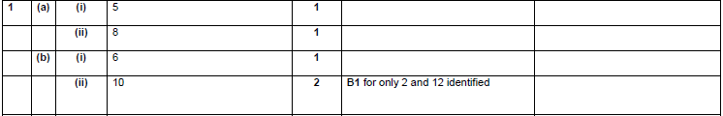

OCR Monday 6 November 2017– Morning (Calculator) Foundation Tier
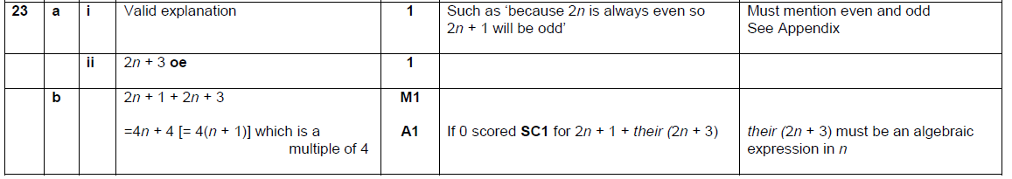

Pearson Edexcel – Sample Papers - Paper 1 (Non-Calculator) Foundation Tier

Pearson Edexcel –Sample Papers - Paper 2 (Calculator) Foundation Tier

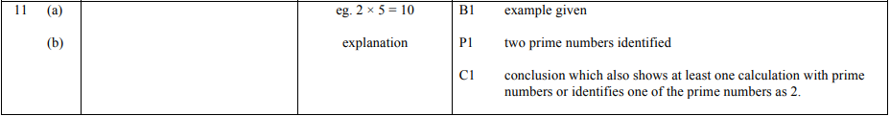
OCR Thursday 25 May 2017 – Morning (Calculator) Foundation Tier

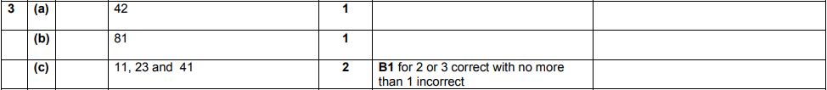

OCR Sample Question Paper 2 – Morning/Afternoon (Non - Calculator) Foundation Tier

AQA Sample Paper 1– Morning (Non-Calculator) Foundation Tier

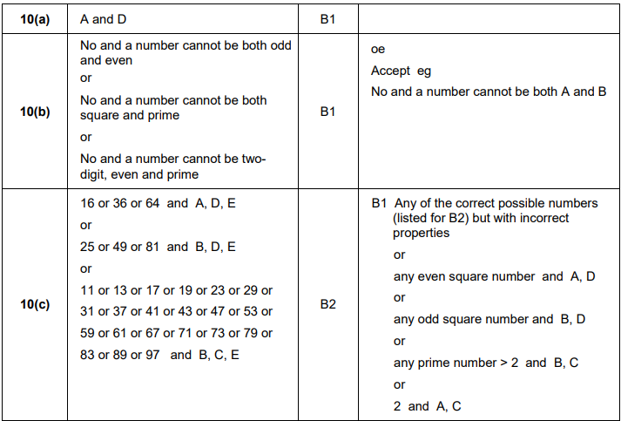
AQA Sample Paper 2– Morning (Calculator) Foundation Tier

